OPEN SOURCE CODING
Module code :OPSC6312
POE – PART 1
PLANNING AND DESIGN DOCUMENT



DUE DATE – 24 August 2026
RAFIQAH KIRBY - ST10438554
Table of Contents
Introduction 3
App overview 4
App name and Logo design: 4
Application Description 4
Target Users 4
Innovative Features 5
Functional and non-functional requirements 6
Functional Requirements : 6
Non-functional Requirements : 7
Complete UI mock-ups 9
Navigation flow diagram 10
API design 11
Database design 12
Data Requirements and Data Types 12
UML diagrams 17
Gantt chart 18
Conclusion 19
References 20

Introduction
The development of mobile technology has changed how customers connect with businesses, making it easier to browse products, place orders, make payments, and contact with service providers. Mobile applications have become essential tools for organizations in the food and catering industry, allowing customers to simply place orders while enabling businesses to manage operations more efficiently.
R&T Halaal Catering is a catering company that specializes in sweet and savoury delicacies, platters, catering pots, and customized catering packages for events such as birthdays, weddings, baby showers, bridal showers, corporate functions, graduations, funerals, and family reunions. Customer orders are now processed manually through channels such as WhatsApp, phone conversations, and social media. Although these approaches are useful for small firms, they can be time-consuming, raise the risk of human mistake, and make it difficult to manage several orders at once.
The goal of this project is to create and build a mobile app called R&T Halaal Catering. Customers will be able to browse various catering products, customize platters and catering menus, place advance orders, select collection or delivery, and pay either a deposit or the entire amount using the application. Customers will also be able to check the status of their orders and offer feedback once their events are complete.
Unlike regular meal delivery apps, this one is built exclusively for event catering. All orders are placed in advance, with consumers picking an event date and completing event details before confirming their order. The application will also help the business owner by offering a management system for products, client orders, payments, reviews, and order statuses.
The application will be built with Android Studio and cutting-edge Android development technologies. Firebase services will be used to handle user authentication, cloud database storage, picture storage, and push notifications. This ensures that client information and orders are securely maintained, while also delivering a dependable and scalable solution that can expand with the company. The ultimate goal of the project is to improve customer convenience, streamline order management, eliminate manual administration, and provide a professional digital platform that will support R&T Halaal Catering's expansion.

App overview

App name and Logo design:
Name: R & T Halaal catering
Logo:


Application Description
R&T Halaal Catering is a smartphone app designed for people looking to book catering services for special occasions. Customers may use the app to explore sweet and savory snacks, platters, catering pots, and catering packages, customize their orders, and schedule collection or delivery for their preferred event date.
Unlike regular meal delivery apps, this one focus solely on advance catering orders. Before their order can be confirmed, customers must select an event date, give event details, and meet the business's minimum order requirements. Customers can also pay in full or make a necessary deposit, with the remaining balance due before or on the event date.
The program will provide client registration, secure login, product browsing, shopping cart functionality, order tracking, payment management, customer reviews, and a company management dashboard. These features are intended to increase customer satisfaction while streamlining R&T Catering's day-to-day operations.

Target Users
The application is intended for:
- Individual customers planning private events.
- Families hosting celebrations.
- Corporate clients organising business functions.
- Schools, churches, and community organisations requiring catering services.
- The owner and staff of R&T Catering for order management.

Innovative Features
- Pre-order catering for future event dates.
- Minimum order quantity validation.
- Build Your Own Platter functionality.
- Build Your Own Catering Menu.
- Catering pot ordering based on guest numbers.
- Automatic quantity recommendations.
- Flexible payment options (deposit or full payment).
- Automatic quotation generation before payment.
- Verified customer reviews after completed orders.
- Real-time order status tracking.
- Administration dashboard for business management.

Functional and non-functional requirements

Functional Requirements :
User Registration
The application shall allow a new customer to create an account using:
- Full name.
- Email address.
- Phone number.
- Password.
User Login
Registered customers can log in using their email address and password.The system will prevent unauthorised users from accessing protected customer information.
Customer Profile
Customers will be able to:
- View their profile.
- Edit personal information.
- Update contact details.
- View saved addresses.
- View order history.
Browse Catering Menu
Customers will be able to browse:
- Sweet Treats
- Savoury Treats
- Platters
- Catering Pots
- Catering Packages
Each product shall display as :
- Product name.
- Description.
- Image.
- Price.
- Minimum quantity where applicable.
- Availability.
Shopping Cart
- Add products.
- Change quantities.
- Remove products.
- View subtotal.
- View delivery charges where applicable.
- View total amount.
Minimum Quantity Validation
The application enforces R&T Halaal Catering's minimum quantity rules. For individual catering products the minimum order quantity is 20. If a customer attempts to order fewer than 20 items, the application shall display an error message.
Order Summary
Before payment, the application shall display:
- Products.
- Quantities.
- Event date.
- Guest number.
- Collection/delivery option.
- Delivery address.
- Total amount.
- Deposit amount.
- Remaining balance.

Non-functional Requirements :
Performance
The application will load the main menu and product information within an acceptable time.
Usability
The application must have simple navigation and clear instructions. A customer will be able to create an order without requiring technical knowledge. Application will be user friendly.
Security
Passwords will not be stored directly by the application. Customer information and order information will be protected using authentication and database security rules.
Reliability
The application will handle temporary network failures gracefully and display meaningful error messages.
Maintainability
The application will use a layered architecture so that the UI, business logic and data access components can be maintained independently.
Scalability
The architecture should allow additional products, users, events and orders to be added without redesigning the entire application.
Compatibility
The application will target supported Android devices and will be tested on both an Android emulator and a physical Android device.

Complete UI mock-ups

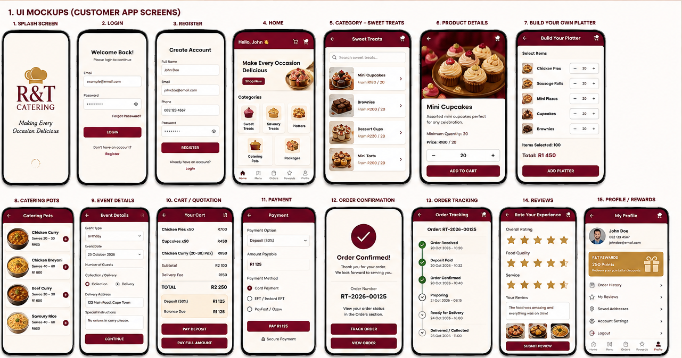

The screen mock-ups show the intended user interface and overall design for the R&T Catering mobile application. Each screen has been created to be easy and user-friendly, allowing clients to easily browse catering options, select items, assemble platters, buy catering pots, provide event details, choose between collection and delivery, and make a deposit or full payment. Customers may track their orders, examine their order history, manage their profile, earn loyalty incentives, and give reviews after placing a purchase. The mock-ups also show how to navigate between the program's various sections and provide a visual depiction of how the final Android application should look and function.

Navigation flow diagram
The navigation structure will be:

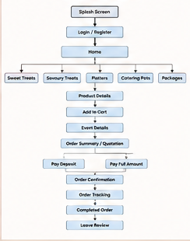

API design
A RESTful API will be developed exclusively for R&T halaal Catering.The API will serve as a communication layer between the Android app and the backend database.The Android app will make HTTP queries to the API, which will return JSON replies.
Architecture will be:
- Android Application
- Kotlin / Android
- HTTPS / JSON
- R&T Catering REST API ASP.NET Core Web API
- Cloud Firestore NoSQL Database
Cloud Firestore is a cloud-hosted NoSQL database that works with Android SDKs, REST APIs, and server-side client libraries. It organizes information into collections and papers.
API Technology
The API will be developed using:
ASP.NET Core Web API
Programming language
C#
Development environment
Visual Studio
Communication
HTTP/HTTPS
Data format
JSON
Hosting
The completed API will be hosted on a cloud hosting platform .
Database
Cloud Firestore.

Database design
Cloud Firestore will be used because it is a scalable NoSQL cloud database that supports Android, offers real-time updates, and has offline capabilities. Firebase also offers authentication and security rules, which can be used with Firestore. The planned collections include:
- Users
- products
- Categories
- platters
- packages
- orders
- orderItems
- payments
- notifications

Data Requirements and Data Types
Users
Field | Data Type | Description
userId | String | Unique customer ID
firstName | String | Customer first name
lastName | String | Customer surname
email | String | Customer email
phone | String | Contact number
role | String | Customer/Admin
createdAt | Timestamp | Account creation date

Products
Field | Data Type | Description
productId | String | Unique product ID
name | String | Product name
categoryId | String | Category
description | String | Product description
price | Double | Product price
minimumQuantity | Integer | Minimum quantity
imageUrl | String | Product image
available | Boolean | Availability

Orders
Field | Data Type | Description
orderId | String | Unique order number
customerId | String | Customer ID
eventType | String | Type of event
eventDate | Date/Timestamp | Event date
guestCount | Integer | Number of guests
fulfilmentMethod | String | Collection/Delivery
deliveryAddress | String | Delivery address
totalAmount | Double | Total order cost
depositAmount | Double | Deposit
balanceDue | Double | Remaining balance
paymentOption | String | Deposit/Full
paymentStatus | String | Payment status
orderStatus | String | Current order status
specialInstructions | String | Customer requests
createdAt | Timestamp | Order creation time

Order Items
Field | Data Type
orderItemId | String
orderId | String
productId | String
productName | String
quantity | Integer
unitPrice | Double
subtotal | Double

Payments
Field | Data Type
paymentId | String
orderId | String
customerId | String
paymentType | String
amount | Double
paymentStatus | String
paymentDate | Timestamp
transactionReference | String
Reviews
Field | Data Type
reviewId | String
orderId | String
customerId | String
rating | Integer
foodQuality | Integer
serviceRating | Integer
comment | String
imageUrl | String
reviewDate | Timestamp

Loyalty Points
Field | Data Type
loyaltyId | String
customerId | String
points | Integer
pointsEarned | Integer
pointsRedeemed | Integer
updatedAt

UML diagrams

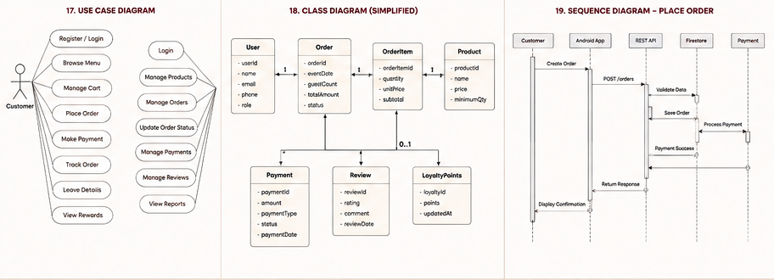

Gantt chart
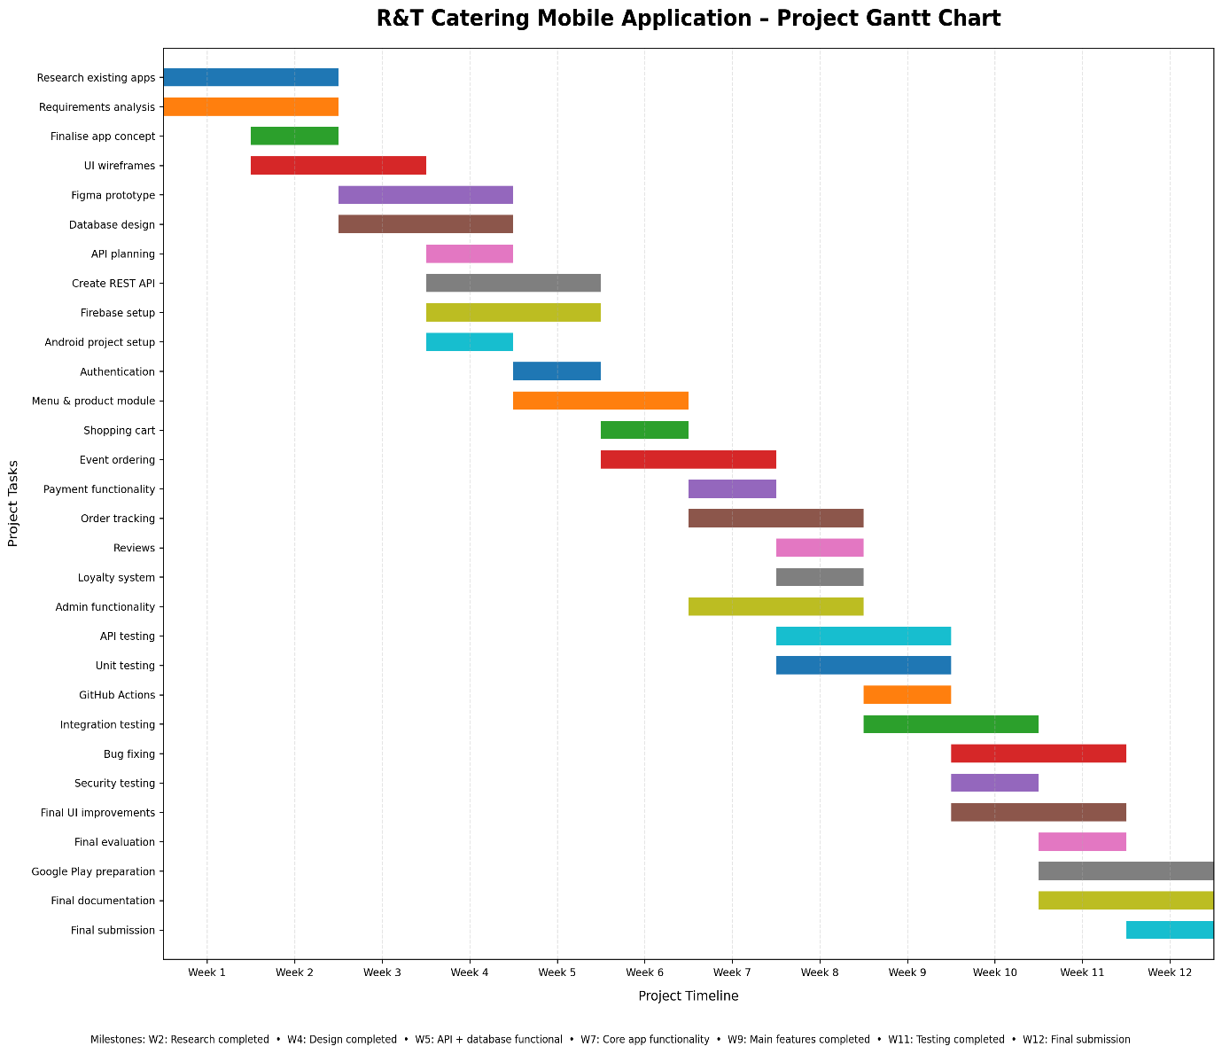

Conclusion
The R&T Halaal Catering was created as a specialized mobile solution for a catering company that operates differently than standard takeaway and meal delivery services. The app focuses on large event pre-orders and offers sweet and savoury sweets, platters, catering pots, and catering packages.
The suggested system meets the specific needs of R&T Halaal Catering by allowing clients to select an event date, number of guests, collection or delivery requirements, and other instructions. The program will enforce minimum quantity limitations and provide clients the option of paying the entire cost or a needed deposit. The quotation, payment, and balance calculations will all be automated to eliminate the chance of manual calculation errors.
Customizable platters, catering pots, customer feedback, loyalty points, and order tracking will enhance the customer experience and set the application apart from other food delivery apps.
The application will showcase the use of Android Studio, Kotlin, RESTful APIs, ASP.NET Core, Firebase Authentication, Cloud Firestore, GitHub, GitHub Actions, and automated testing. The API will serve as a structured communication layer between the Android application and the backend services, whereas Firestore will provide cloud-based data storage.
The detailed requirements, interface designs, navigation structure, API design, database structure, UML models, testing strategy and project schedule provide a complete blueprint for the development phase.

References
Android Developers. (2026). Android Developers Documentation. Available at: https://developer.android.com/ (Accessed: 20 August 2026).
Android Developers. (2026). App Manifest Overview. Available at: Android Manifest Documentation (Accessed: 19 August 2026).
Android Developers. (2026). Compose UI Architecture. Available at: Compose UI Architecture (Accessed: 24 August 2026).
Firebase. (2026). Cloud Firestore Documentation. Available at: Cloud Firestore Documentation (Accessed: 19 August 2026).
Firebase. (2026). Add Firebase to Your Android Project. Available at: Firebase Android Setup (Accessed: 21 August 2026).
Firebase. (2026). Get Started with Cloud Firestore. Available at: Firestore Quickstart (Accessed: 24 August 2026).
GitHub. (2026). GitHub Actions Documentation. Available at: GitHub Actions Documentation (Accessed: 20 August 2026).
Pressman, R.S. & Maxim, B.R. (2020). Software Engineering: A Practitioner's Approach. 9th ed. New York: McGraw-Hill.
Sommerville, I. (2021). Software Engineering. 11th ed. Harlow: Pearson.

